

Belair Elementary School

***Parent and Family Engagement Policy and Plan for Shared Student Success***

*Plan Revised 5.1.25*

*2025–2026 School Year*

#### Belair Elementary School Shetina Roulhac, Principal 3925 Harper Franklin Ave

*(706)821-2766*

[*www.rcboe.org*](http://www.rcboe.org/)

# What is Title I?

Belair Elementary School is identified as a Title I school as part of the Every Student Succeeds Act (ESSA). Title I is designed to support State and local school reform efforts tied to the challenging State academic standards to improve teaching and learning for students. Title I programs must be based on effective means of improving student achievement and include strategies to support family engagement. All Title I schools must

jointly develop with parents and family members a written

parent and family engagement

policy.

# School Plan for Shared Student Achievement

## What is it?

This is a plan that describes how Belair Elementary School will

provide opportunities to improve family engagement to support

student learning. Belair Elementary School values the contributions \

and involvement of parents and family members to establish an

equal partnership for the common goal of improving

student achievement. This plan describes the different ways that Belair Elementary School will support family engagement and how parents

can help plan and participate in activities and events to promote student learning at school and at home.

## How is it revised?

Belair Elementary School invited all parents to attend our annual School Revision/Input Forum last spring to review and revise this parent and family engagement policy, as well as the schoolwide plan, our school-parent compact, and the family engagement budget. Additionally, parent input and comments regarding this plan are welcome during the school year. The plan is posted on our school website for parents to view and submit feedback throughout the year. All parent feedback received during the year will be used to revise the plan for the next school year. We also distribute an annual survey online to ask parents for their suggestions on the plan and the use of funds for family engagement. Parents and family members can also give feedback during several parent meetings and activities during the school year. If the plan is not satisfactory to the parents of participating children, the school will submit any comments to the district office.

## Who is it for?

All students participating in the Title I, Part A program, and their families are encouraged and invited to fully participate in the opportunities described in this plan. Belair Elementary School will provide full opportunity for the participation of parents and family members with limited English, with disabilities, and of migratory children.

## Where is it available?

At the beginning of the year, the Richmond County Parent and Family Engagement Plan is included in the student code of conduct book that is given to all students. The Belair Elementary Parent and Family Engagement Plan will also be posted on the school website and distributed at the Title I Annual Meeting. Parents can also retrieve a copy of the plan in the Parent Resource Center.

### 2024–25 District Goals

***District Goals***

Decrease the percentage of beginning learners in identified schools by 10 percentage points in ELA and Math as measured by GMAS (Elementary ELA from 59% to 49% and Elementary Math from 60% to 50%.

**2025–26 District Goals**

***School Goals***

By May 2026, the percentage of students reading on Grade level in grades 3-5 will increase from 59% to 69% as measured by EOG Reading GMAS.

By May 2026, the percentage of students scoring proficient or better from 29% to 39% as measured by EOG Math GMAS.

By May 2026, Belair Elementary School will increase our school climate star rating from 2 stars to 4 stars.

By May 2026, instructional staff will complete 4 PL's focused on research-based strategies, collaboration, and reflection evidenced by Eleot reports.

# School-Parent Compacts

As part of this plan, Belair Elementary and our families will develop a school-parent compact, which is an agreement that parents, teachers, and students will develop that explains how parents and teachers will work together to make sure all our students reach grade-level standards. The compact will be reviewed and updated annually based on

feedback from parents, students, teachers and all other

stakeholders. The school- parent compacts are shared with parents during open house, the Title I Annual Meeting, online, during parent teacher conferences

**Let’s Get Together!**

Belair Elementary School will host the following events to build the capacity for strong family engagement to support a partnership among the school, parents, and the community to improve student academic achievement. Most meetings for parents and family members will be held in the morning before school, during the day by appointment and in the evening at 6:00 pm. for special events.

##### Parents As Students & PTO –

Parents experience in one night what their child(ren) experience daily in the classroom.

##### Book fair-10/24/25

##### Grand Parents eat lunch with Students-9/4/25

Come purchase a book from the fair and eat lunch with grandchildren.

##### Volunteer Workshop, PTO & Annual Title I Meeting-9/18/25

We invite you to an evening of learning about our Title I program, family engagement policy, the schoolwide

plan, and the school-parent compacts. Information provided via flyers, the marquee and the school webpage.

##### Math’s Not Spooky, Volunteer Workshop & PTO– 10/30/25

Play some math games with your child and learn how to make math fun at home.

##### Parent-Teacher and Student Conferences – 9/12/25

Scheduled updates on your child’s progress.

##### Thankful for Literacy Class visits –

Students will receive visits from guests whom will read/share a book with them.

##### Family Fun Night-3/12/26

##### STEAM, PTO & Science Fair :Curriculum Night-11/18/25

Catch up with the latest resources in science, technology, engineering, arts, and math to help support your child’s learning.

##### Underground Railroad (in school field trip)-

Gain knowledge about Black History people and topics relevant to your child’s education.

##### Book Fair- 2/20-27/26

Come purchase a book from the fair

##### Parent-Teacher Conferences – 2/17/26

Connect with teachers about how your child is progressing academically.

##### Teacher Appreciation-5/4-8/26

Take time to thank a teacher and show appreciation for those who help shape your child.

##### Georgia Milestones Testing Window-4/22-4/28/26

GMAs testing window for 3rd -5th grade students.

***School Input/Revision Forum –*** Roundtable discussions with staff regarding the schoolwide plan, policy, compacts, and the budget.

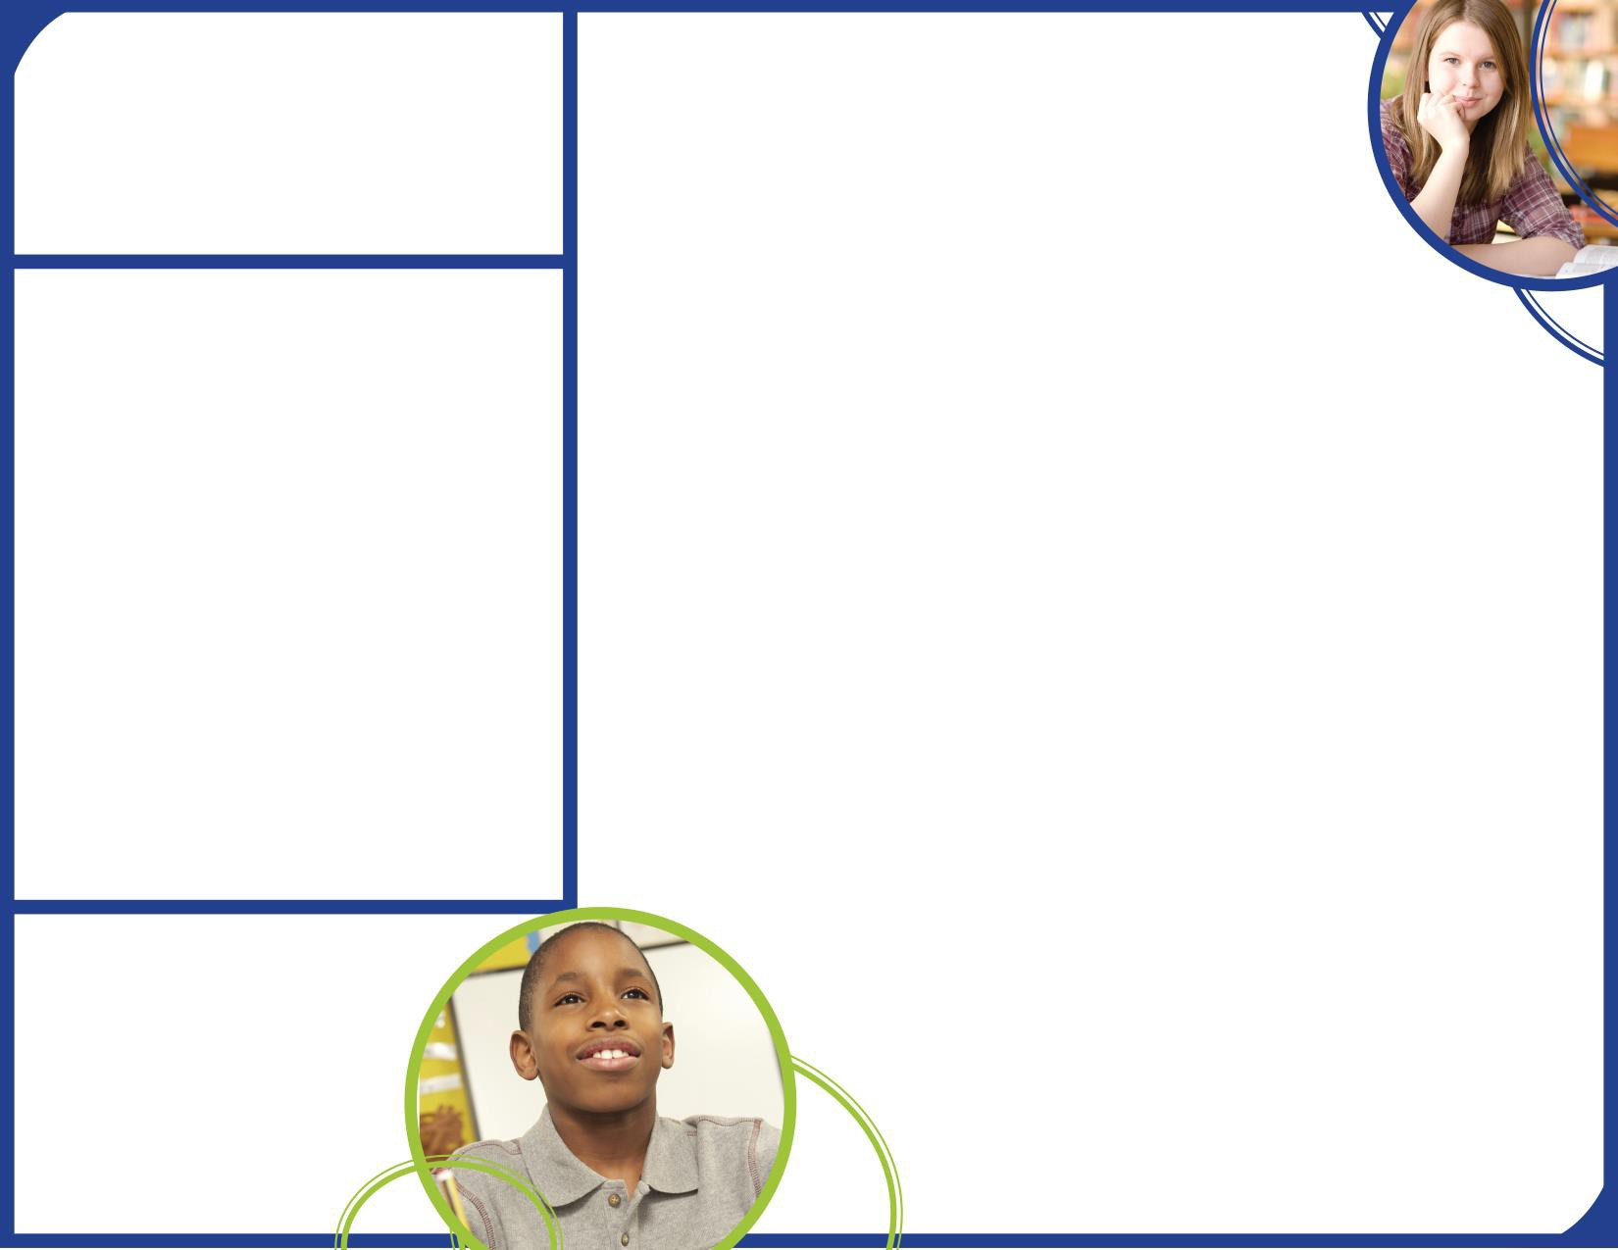**Parent Resource Center**

Come visit the Parent Resource Center (Media Center) to check out books, study materials, and activities to use at home with your child. Computers are available for parents to explore the Parent Portal and educational resources.

Monday – Friday, 9:00 am – 3:00 pm

**Parent and Family Engagement**

Belair Elementary School believes that family engagement means the participation of parents and family members in regular two-way, and meaningful communication involving student academic learning and other school activities, including ensuring:

* That parents play an integral role in assisting their child’s learning.
* That parents are encouraged to be actively involved in their child’s education at school.
* That parents are full partners in their child’s education and are included, as appropriate, in decision-making and on advisory committees to assist in the education of their child.
* The carrying out of other activities as described in this plan.

Belair Elementary School is committed to helping our parents and families attend the family activities listed in this policy.

Please call us if you need assistance with

child care or transportation in order to participate in our programs. We must have a 48 hour notice.

(706)821-2766 (ask for Ms. Trimmingham)

## Belair Elementary School is Branching Out!

Belair Elementary School will take the following measures to promote and support parents and family members as an important foundation of the school in order to strengthen the school and reach our school goals. We will:

* + Ensure that all information related to school and parent programs, meetings, and other activities is published in an understandable format and language and posted on the school website.
  + Provide trainings for staff on strategies to improve communication with parents and ideas to increase family engagement with reading and math activities for our students outside of the classroom. Staff will also share best practices during regularly scheduled faculty meetings.
  + Partner with early childhood programs*,* middle schools, college and career ready resources or organizations, parent resource centers, or other programs (as applicable) to help prepare parents and their children for successful school transitioning.
  + Share information for parents to understand the school’s curriculum, academic standards and assessments as well as the ways parents can monitor their child’s progress and work with educators. Provide parents with individual student assessment results and interpretation of those results.
  + Communicate with all families and the community on a regular basis regarding schoolwide events and activities, through phone messages, the school website, class dojo, flyers, in-person, virtual meetings, and parent-teacher conferences.
  + Work with our parents to develop relevant trainings and helpful presentations to educate our staff on the importance of parent and family engagement and how to support student learning.
  + Provide necessary materials and handouts for parents at conferences, meetings, and activities to help parents work with their child to improve their child’s achievement. These meetings

will be offered at various times (morning and evening) and in various formats.

* + - Offer Infinite Campus account set up and assistance with usage for parents and family members to monitor their student’s progress.
      * Collect feedback from parents and family members at all events and post a survey on the school website in order to respond to parents’ requests for additional support for parent and family engagement activities.

# Parent and Family Engagement Standards

Belair Elementary School and our parents have adopted the National PTA Standards for Family-School Partnerships as the school’s model in engaging parents, students, and the community. These standards are:

1. Welcoming All Families
2. Communicating Effectively
3. Supporting Student Success
4. Speaking Up for Every Child
5. Sharing Power
6. Collaborating with Community

# Building Capacity of Parents: School Council

Belair Elementary School has developed a School Council to share ideas and ways to involve other parents and family members to build partnerships with school, families, and the community. The School Council meets four times during the school year, but all parents and family members can also submit their ideas or suggestions at any of the school activities and meetings, as well as through our parent surveys and website. Besides school council, we will also share information through i-Ready Reports (quarterly) and the Georgia Standards of Excellence.

# School Volunteer

* Yes, I am interested and wish to be trained and join the School Volunteer Team.
* Please contact me so I can learn more in joining the School Volunteer Team.
* Please send me notifications about future Volunteer Training Workshops.

Name: Child’s Name and Grade: Address: Phone Number: Email address:

# Share Your Thoughts

We want to hear from you. If you have any suggestions or if there is any part of this policy that you feel is not satisfactory with the students’ and the school’s goals for academic achievement, please provide us with your comments in the space provided and leave this form in the Main Office:

Name: (optional) Telephone Number: (optional)

